Radar Config and Measurement Tool

The Radar Config and Measurement Tool (RCM Tool) combines the DSP_TOOL Excel Sheets and the Test Script 3 Excel Sheets inside a single software solution for the following boards/modules:

* A: Tank Gauging
* B: BGT24
* D/E: RRC01
* F: Fractional-N PLL
* G/H: RRC160

Contents

1 Using the Software 2

1.1 Menu Strip 3

1.2 Tab Control 4

2 Configuration and Automation Files 5

2.1 Radar Config (*.rcfg) 5

2.2 Radar Automation Script File (*.rasf) 6

# Using the Software

The RCM Tool consists of several Tabs that will be shown according to the selected module. Furthermore it has a menu strip with several options.

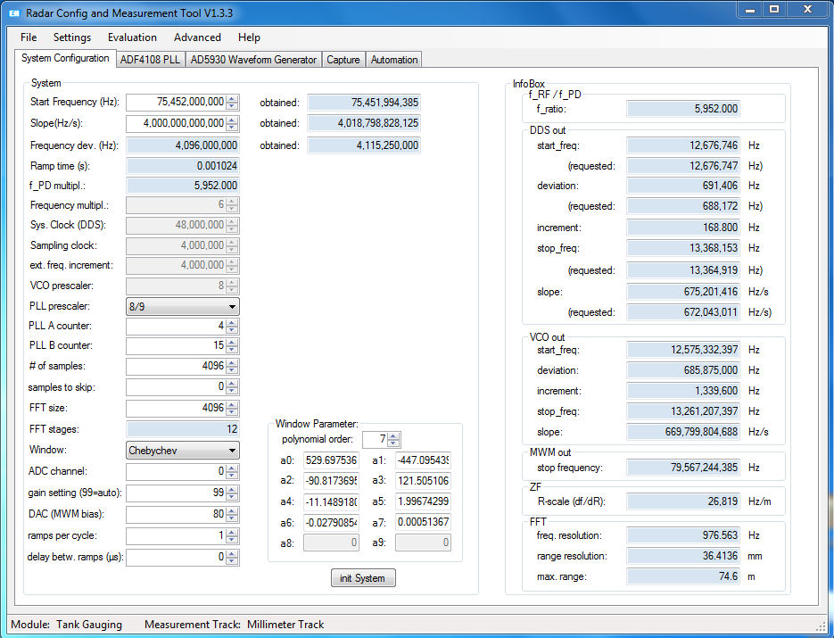

## Menu Strip

File

| -> Load Configuration Loads a *.rcfg file which contains a module configuration

| -> Save Configuration Stores the actual configuration into a *.rcfg file

| -> Load Default Configuration Loads the default configuration of the actual selected module

| -> Create Automation Script GUI to create a *.rasf file (automated measurement script)

| -> Close Closes the tool

Settings

| -> Select Board Changes the actual board/module

| -> Select Measurement Track Changes the measurement track

| -> Capture Settings

| -> Capture RAW and FFT data to *.png Also save *.png files while capturing data

| -> Change DSP Com Selection of the COM-Port of the CDI Service Box

Evaluation

| -> Save Matlab Evaluation files Saves Matlab Evaluation Script

Advanced

| -> Enable Advanced Settings Enables/Disables the advanced settings

| -> Enable Debug output Stores *dbg files with debug output during Automation

| -> Set Automation Waiting Time Sets the time between motor position change and capturing

data. This time should prevent the reflector wall from swinging

| -> Get Module Information Shows the connected module version by reading information

from DSP

Help

| -> Documentation Opens this document

| -> About Shows the about screen including the revision history

## Tab Control

Depending on the selected board and if the advanced mode is enabled different tabs will show up in the main screen. Blue background indicates that these values are calculated from other values and are only for information. Greyed values are hardware specific or fixed values. These values can only be changed when advanced mode is enabled. If the advanced mode is enabled these values will be indicated in red.

There are the following tabs:

* **System Configuration:** Basic system setup. By pressing “init System” the values (also from the module specific tabs) will be written to the module. This tab will always be shown.
* **Module specific (ADF4108, AD5930, HMC703, …):** Module specific system settings (e.g. PLL settings, DDS settings, …). Here different tabs will be shown for different modules. Some of the settings in these tabs can’t be changed (also not in advanced mode) as they will be set according to values from the system configuration tab (shown with blue background)
* **Track Control:** This tab will only be shown if advanced mode is enabled. In this tab the measurement track and the laser tracker can be controlled. Only use these functions with caution!
* **Capture:** In this tab the raw data and the spectrum calculated by the module can be captured and plotted. By pressing “start single capture” the values will be plotted in charts until “stop single capture” is pressed. Furthermore a given amount of data can be saved inside a *.csv files by checking “capture to csv”. If Settings -> Capture Settings -> Capture RAW and FFT data to *.png files is selected the plots will also be saved as *.png files next to the *.csv files
* **Automation:** In this tab an automated measurement on the measurement track can be started. Therefore an automation script (*.rasf) has to be selected. A graphical user interface started from File -> Create Automation script assists creating these files. The shown log screen can additionally be stored into a log file. This is useful for longer automations, because the log file can be saved into cloud services like dropbox and can therefore be monitored outside the E+H network (In the log file no confidential information will be saved. Just the actual progress will be saved into the file)

# Configuration and Automation Files

## Radar Config (*.rcfg)

This file contains all the settings of a module and be loaded from File -> Load Configuration. The actual set configuration can be stored in a *.rcfg file by selecting File -> Save Configuration.

The Radar Config File is in xml format and has different attributes for different modules.

Here is an example of a Radar Config File for the Tank Gauging module:

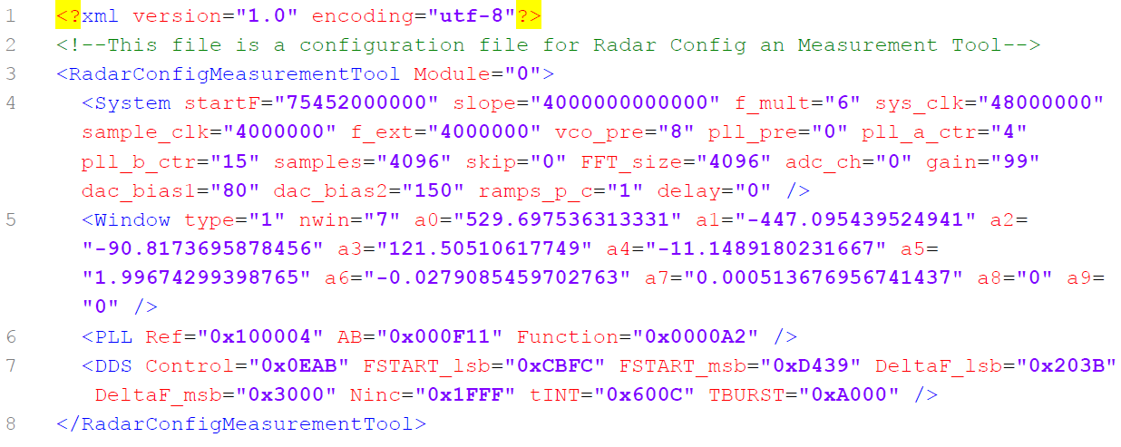

## Radar Automation Script File (*.rasf)

The Radar automation script can be created with graphical user interface by selecting File -> Create Automation Script.

**1st step: Basic setup**

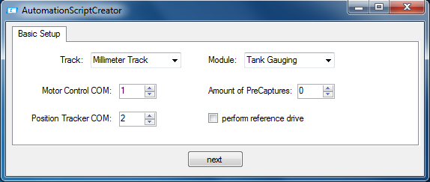

* *Track:* Selection of the measurement track
* *Module:* Selection of the module
* *Motor Control COM:* COM-Port number of the motor control of the measurement track
* *Position Tracker COM (only if available for selected track):* COM-Port number of the position tracker/laser tracker of the measurement track
* *Amount of precaptures:* Amount of not saved captures before the real task is started. This is necessary if e.g. automatic gain control is activated, because for the first captures the gain is not set yet.
* *Perform reference drive:* Check if a reference drive of the Motor Control has to be performed before the first task is started.

**2nd step: Track configuration (only if available for track)**

Here different settings for the selected track has to be given.

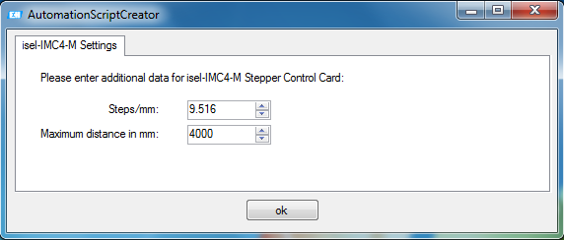

**3rd step: Task definition**

Here different tasks can be created. By pressing add task the actual set task will be added. By clicking create the *.rasf file will be created.

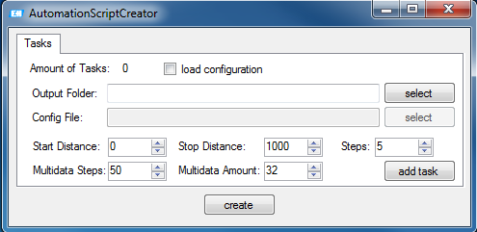

* *Load configuration:* If this is checked a Radar Configuration (*.rcfg) is written to the module before the task is started. If not checked the configuration won’t be changed.
* *Output folder:* The path where the data will be stored to (in subfolders representing the set distance)
* *Config file:* The Radar Configuration (*.rcfg) that will be loaded before the measurement is performed. Only available if load configuration is set.
* *Start distance:* The first position (mm) of the automation task.
* *Stop distance:* The last position (mm) of the automation task.
* *Steps:* The stepsize (mm) between two measurements of the automation task.
* *Multidata Steps:* The stepsize (mm) between two multidata measurements of the automation task. A multidata measurement is a measurement distance where more than 1 measurement is performed.
* *Multidata Amount:* The amount of measurements that will be performed at a multidata measurement.

Here is an example of a Radar Automation Script File:

